|  |  |
| --- | --- |
| **Name:** | Roslin Punnoose |
| **Student No:** | N9319751 |
| **Unit code:** | IFB299- Application Design and Development |
| **Assessment** | Personal Portfolio |
| **Team Number** | Group 12 |

**Release 1 Artefacts (5 Items)**

**Artefact 1**

Task: *Created mock ups for the following parts of the user interface:*

1. Order Form with Customer details
2. Order Form with Receivers details
3. Order Confirmation Form.

Description:

I have used wireframes.cc website to create the mockups for the above mentioned pages.

* Order Form with the Customer details includes
* Name of the Customer
* Email address
* Contact Number
* Address
* Order Form with the Receivers details includes
* Receiver Name
* Receiver Contact Number (Optional)
* Destination
* Order Confirmation Page
* List of all the Order Form details
* Button to Confirm the order.

Benefits of Artefacts to the project:

* While creating the mockups for the pages, as team we were able to point out some of the problems regarding the designs.
* In addition to that, as the developers, the mockups help us to get a clear idea of how the order form and confirmation pages looks like.
* The mockups were also shown to the client’s team to get their feedbacks regarding the design.
* As a team this eventually helped us to create a professional look for the order form and Confirmation page.
* Feedbacks given by the client:
* Reorder the attributes
* Avoid attributes like city, Country
* Even though changes are made, these mockups are considered to be the basics for the design.

Evidence:

1. Order Form with Customer details

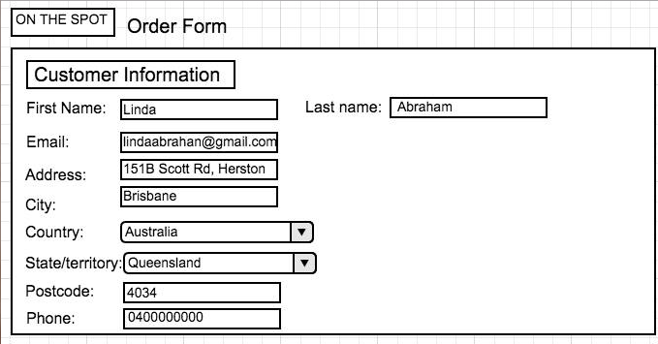

* First Mock-ups created (before receiving feedback from the client)

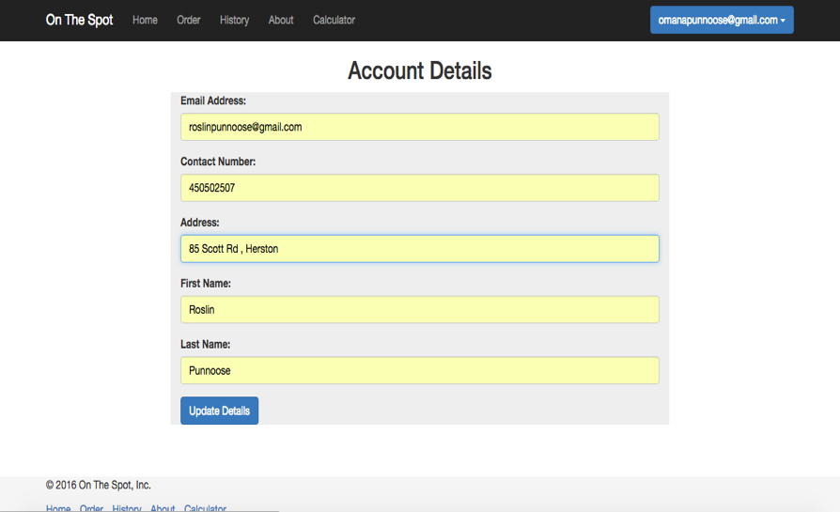

* Screenshot of the Actual website after getting feedback from the client

1. Order Form with Receivers details

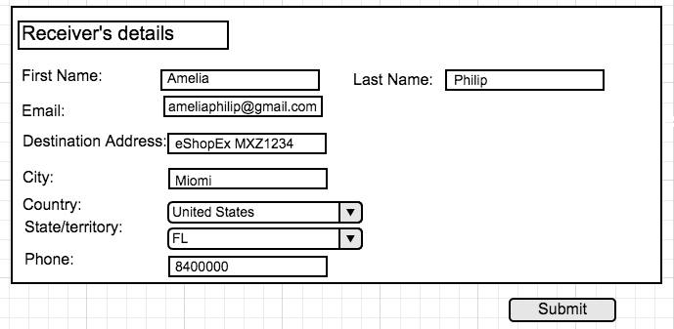

* First Mock-ups created (before receiving feedback from the client)

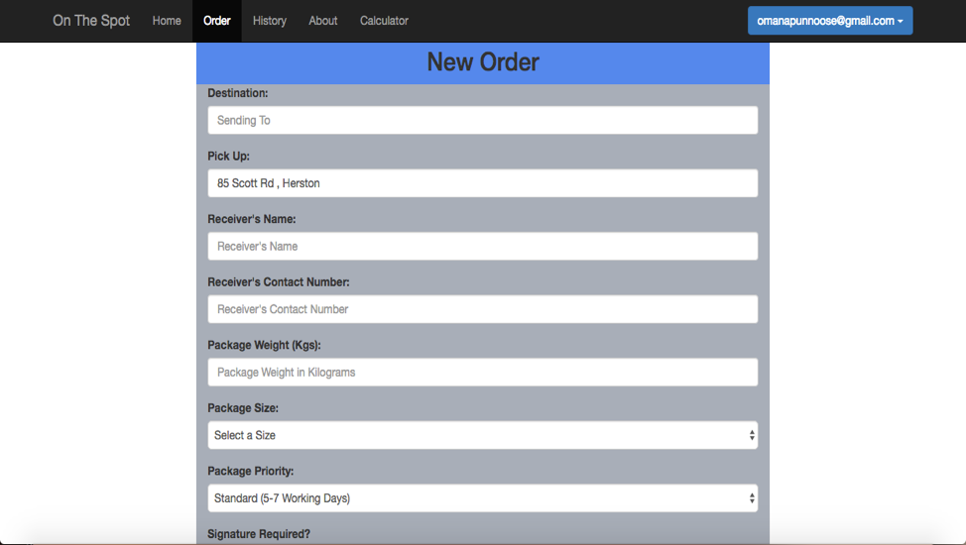

* Screenshot of the final website. (from Release 2)
* Additional package attributes are added because its included in release 2
* Order Confirmation Form. [First Mock-ups created (before receiving feedback from the client)]

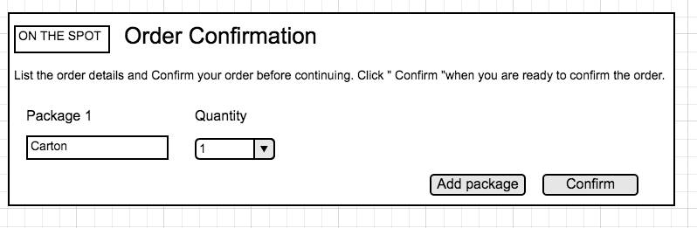

**Artefact 2**

Task: *Developed ‘Data flow diagram’ to visualize the overview of the web application (On the SPOT):*

Description:

I have used visual paradigm tool to develop the Data flow diagram of the website.

This mainly includes the following things:

* Step-by-step flow chart diagrams.
* The web page that shows the input as well as the output of the data from the websites along with images.

Benefits of Artefacts to the project:

* The development of data flow diagram, helps us to know the frontier of our system. (For instances, shows the web page before the input details are given as well as its corresponding output.)
* With the help of the data flow diagram, we the developers got an idea regarding, on how the end users will communicate (or expect) with the website.
* It mainly denotes the different system used in the entire process.
* If the client teams are unsure on how to use the website, this data flow diagram helps them to get an idea regarding how to use it or what can be the expected outputs.

Evidence:

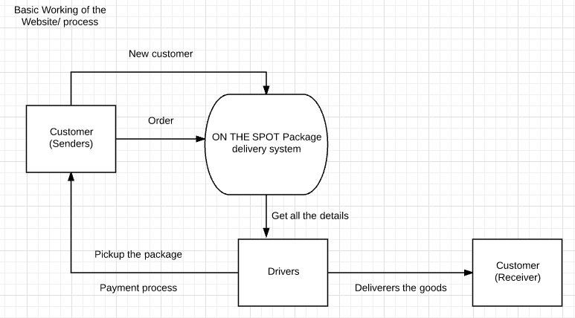

* Basic working of the process and the website.

The below Data flow diagram displays order entry including business process, data, attributes and sequential flow of the data.

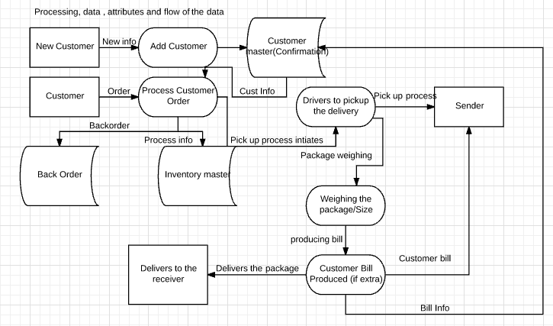

Integrating the data flow chart with the Web page

In the above data flow diagram, it clearly depicts that as soon as the customer makes an order, it redirects the user to the page in which the order process and the confirmation is displayed before submitting. Below is the evidence for this.

E.g.: Creating an order

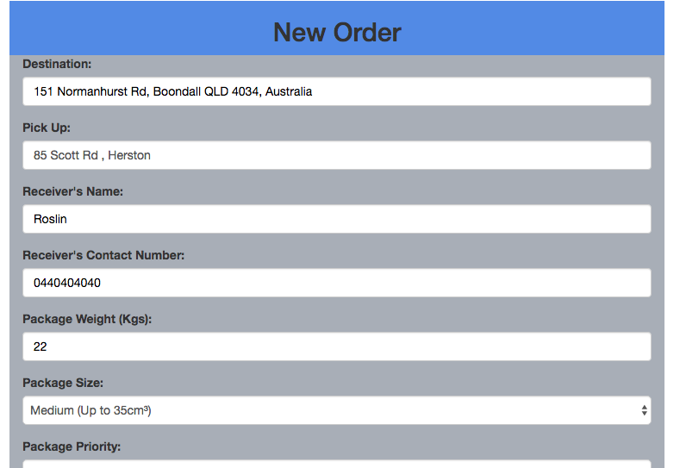

* Order details page that shows the data input

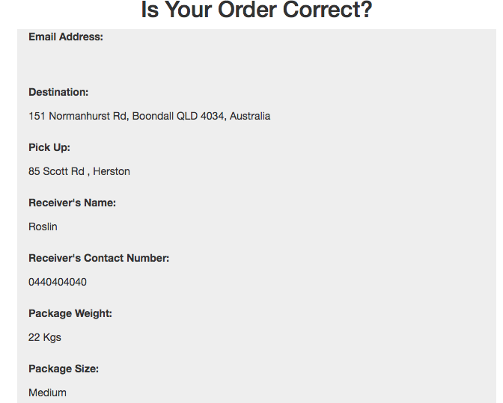

* As soon as the order page is created, the web page then navigates to the page where it contains the order info and as well as confirmation which shows the output data along with the price details (This is to verify with the customer, regarding the details entered before they submit.)

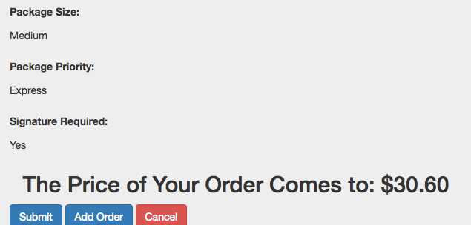

**Artefact 3**

Task: *Helped the team to draft the business letter for the peer review 1*

Description of my contribution to the business letter:

The business letter was drafted in such a way that initially all the questions given in the “End of the Sprint Review” document was listed down in a google docs and was shared with all of the members within the group. So all of us can work together.

As a team we mainly concentrated on the content (Discussion of the demonstration). This discussion includes different aspects, such as

* Preparedness made by the team.
* Expectations.
* Technical aspects.

I was able to provide some feedbacks regarding the preparedness of the team on the basis of their demonstration along with other team members.

My point of view for their preparation and demonstration of the product was regarding the professionalism they had during the demo and their high level of showcase skill. This feedback could be benefit to them as well as ourselves in such a way that it encourages the development team to continue by following the same criteria and us to meet that expectations.

I was also able to figure out that the development team has not demonstrated all of the user stories mentioned in the sprint plan. Therefore, this might help them to make sure that all of the user stories to be completed before the next demonstration. In addition to that, I gave the feedback about their great confident level in respect to the implementation of the acceptance criteria, but the above mentioned problem was once again an issue here.

In regardless to the expectations, I noticed that their demonstration was focused to the right level of stakeholders and performed the demo with no technical issues. I was also able to give opinion regarding their professionalism in presentation by pointing out clarity of the speaker and his ability to make the client understand the process well during the demonstration.

All of these feedbacks were reconstructed in order to include that in the business letter. All together, I was able to successfully contribute to the assessment. This eventually helps our team to meet the expectation level in order to compete with the other team.

Evidence:

The below attached is the business letter of the Peer Review 1 (Demonstration) which includes all the content written by each of the team members. The part which is ***highlighted with the green colour*** denotes my contribution to the business letter.



*Double Click here to view my contributions for the letter -*

**Artefact 4**

Task:  *Refined the acceptance criteria of the user stories by prioritizing it using the Moscow method (Result to formation of the Release and sprint plans)*

Description and benefits of artifact:

I have used Moscow methodto improvise the acceptance criteria. The main reason to use this technique is to decide the significance level of all client requirements. To elaborate, prioritizing the user stories into Must have, should have, could have and Wont have.

As it is a team work, all of us participated in doing the prioritization. Therefore, we created a google docs and listed all the user stories that we have made earlier. Individually, we started prioritizing for some of the user stories. As a result, on this bases we made the release and sprint plans for the whole semester.

Out of 18 user stories, is categorized 11 of them to be Must have, 6 to be Could/Should have and finally one of them to be Wont have.

All of the must haves are included in the release 1 and rest in the release 2. This was finalized when the client team agreed to it.

Examples using the Moscow technique:

For instance, in my point of view the ability of the customer to make delivery orders online is considered to be most important than enabling the owner to document the payments online. This why the first one (making delivery orders online) is included in the Must have category. Whereas the second user story is unavoidable and important, so therefore its included in the Should have category.

Similar to this, I did the prioritization for the having multiple packages, see the completion of the delivery and the view the website. In addition to that, I did the prioritization for entering and viewing the size and other details of the package.

Evidence:

The below attached is Prioritised user stories done by all the team members. The sentence written in blue, rose and red denotes Must have, should have/ could have and Wont have priority. The part which is ***highlighted with the blue colour*** denotes my contribution to the prioritisation.

*Double Click here to view my contributions -*



Benefits to our project

As soon as the prioritisation is done, with the help of this document we started creating the release and sprint plans.

Below attached is the some of the screenshot of the Must have and Could have that I have prioritised.

**Release 1**

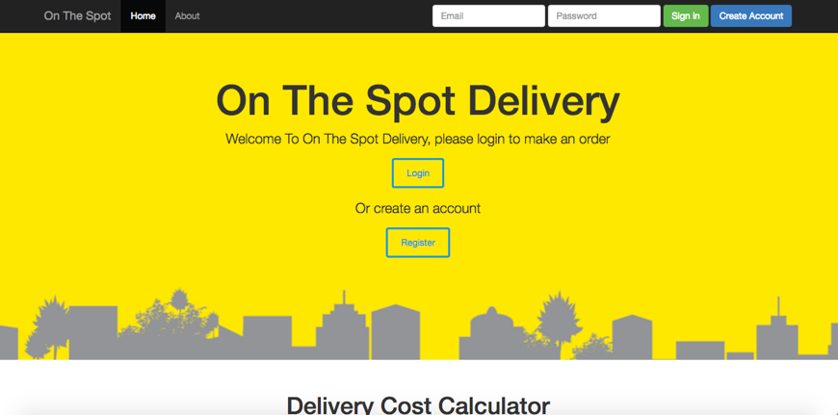

* Screenshot of the front view of the website
* This was done in release 1, because it was prioritised as Must have

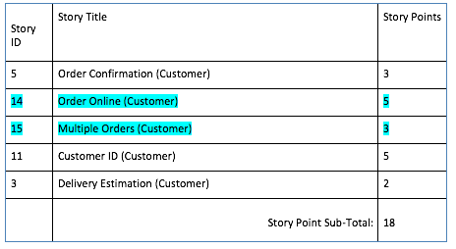

* Screenshot of the Release and sprint plan according to the prioritisation (Must have)

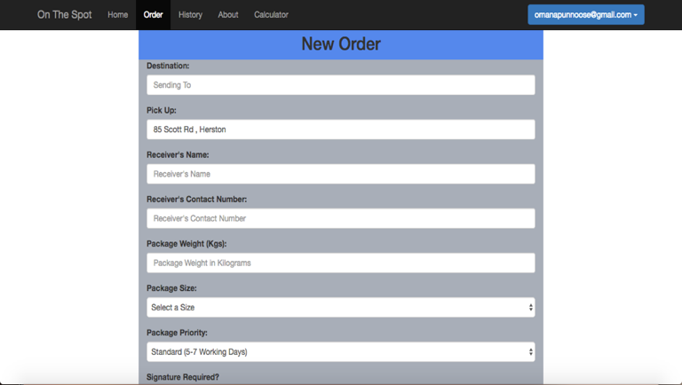

Screenshot of Ordering Online Screenshot of Multiple orders

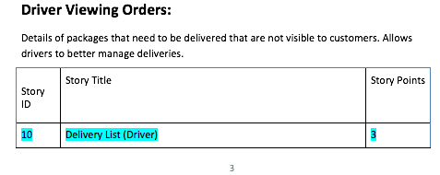

* Screenshot of the Release and sprint plan according to the prioritisation (Must have)

**Release 2**

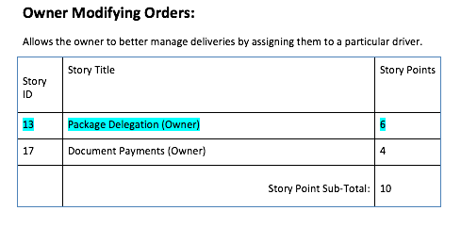

* Screenshot of the Release and sprint plan according to the prioritisation (Should/could have)

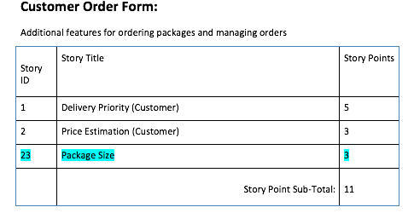

* Screenshot of the Release and sprint plan according to the prioritisation (Should/could have)



* Screenshot of the the website showing the package details.

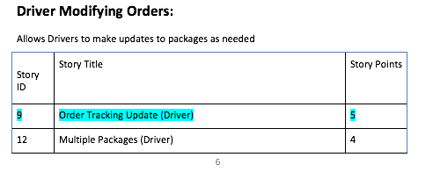

* Screenshot of the Release and sprint plan according to the prioritisation (Should/could have)

**Artefact 5**

Task:  *Designed User Interfaces by integrating the user requirements.*

Description

Here, I mainly focused to make a change in the way in which the user interacts with the buttons of the order confirmation page.

The main reason to do the redesign is to make sure that our website obeys the “Web Design Principles”. This principle includes

1. **User Experience**
2. **Visual Design**
3. Page Layout
4. Standards
5. Mobile Design

Out of these principles, I felt that redesigning helps the user to create a good interaction and visual design with the website.

I made changes to the UI design of the order confirmation page.

1. Changed the colour of the “Submit order” as well as the “Add order” to blue, were the letters inside are highlighted with white colour.
2. The design for the cancel button is changed in such a way that it looks different from other buttons.
3. Apart from this, as soon as the user click any of the buttons, it highlights to a darker shade which literally means that the order is ready to submit, cancel or even add.

Evidence:

Below attached is the evidence of the redesigned UI’s:

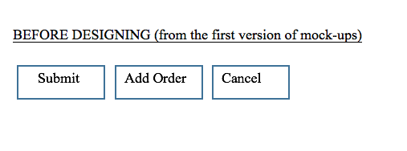

* Screenshot of the UI designs of the website during the initial stage of development.

Screenshot of the redesigned UI’s from the website.

Screen%20Shot%202016-10-27%20at%201.18.49%20PM.png

Benefits to our website

During the demonstration of the Release 1, the client team was **very satisfied** to see the overall look of the website. This is because, due to the redesign, it makes the website looks user friendly and easy to use. In conclusion, it can be stated that the redesign of the UI interfaces has **upgraded the product’s efficiency**.

The above described are the 5 artefacts (task, description, evidence and benefits) that I have worked on during the Release 1.

**----------------------------------------------------------------------------------------------------------------**

**Release 2 Artefacts (5 Items)**

**Artefact 1**

Task: *Modelled the business process of package delivery using BPMN 2.0 process modelling language.*

Description

I used a software named Signavio to model the business process of the package delivery. Even though the data flow diagram shows the entire process, it does not specify the step by step process in which the user interacts with the websites. To elaborate, it illustrates all the steps from the beginning (where the customer decides to make an order) till the end (order fulfillment)

The model consists of a start event, Activities, decision making and end event. It also considers the multiple perspectives of the user. From instance After making an order the customer can either submit or add multiple orders or even cancel it. This is modelled with the help of a decision making gateway known as XOR gateway. Likewise, there are many other decision making in some part of the website.

Evidence:

***Screenshot of BPMN model from the customer perpesctive.***

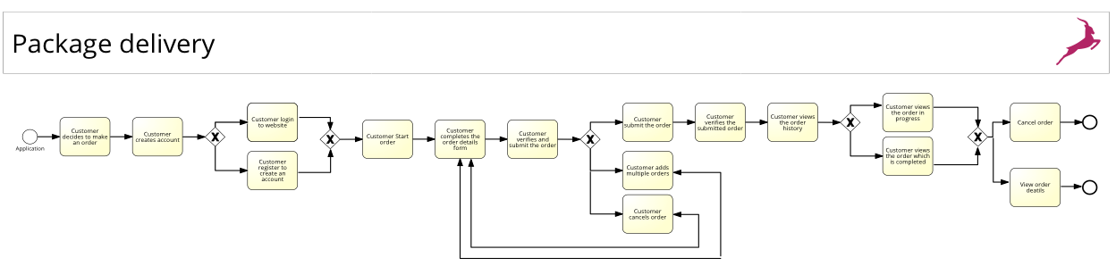

Benefits to our website

* The main objective for modelling the business process is to Upgrade the design of the website.
* The BPMN diagram that I made also helps us (developer team) to get a clear idea about the navigation of the website from one page to the other.
* It improves the communication process on the basis of the decision made by the user.

**Considering a small portion of the BPMN diagram**

Below is the screenshot of a small part of the BPMN diagram.

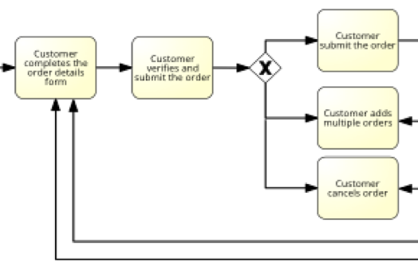

Figure 1

The up coming screenshot depicts the importance of the above BPMN screenshot (Figure 1) in package delivery website.



* As modelled in the BPMN diagram (Figure 1) this is the screenshot of the order details page. Here the user submits the order details, which eventually take them to the confirmation page of the order details (the next screenshot)
* As soon the user submits the order details, the website then navigate to the confirmation page of the order details, were it has three option to either Submit, Add order and cancel.
* The user can choose any of this according to their needs.

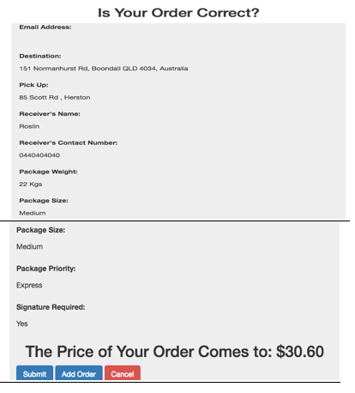

* If the user submits the confirmation of the order details page, it then navigates to another page which notifies the user regarding the order process (whether it is successful or not)





* On the other hand, If the user chose to add or cancel the order, the website then navigates to the order details pages.

* So that they could make other orders.
* Also cancel the order that they made and start a new order

This is how the the BPMN diagram help to improve the design of the system.

**Artefact 2**

Task: *Did research regarding the pricing scheme for the Order details page.*

Description:

The research was mainly to find out the general package size/ weight/ priority for package delivery.

I was able to come up with the following information.

1. Maximum weight of the package which is 22kg
2. Different size of the package

* Envelop (Up to 22cm x 33.5cm)
* Small (Up to 20cm-cubed)
* Medium (Up to 35cm- cubed)
* Large (Up to 45cm- cubed)
* X- Large (Up to 70cm- cubed)

1. Priority for package

* Standard (5 -7 working days)
* Express (2 -4 working days)
* Overnight (1 working day)

With the help of this information, the user can pick up the options that they prefer. And estimate the amount of money they need to pay.

Evidence:



*Double Click here to view the evidence of my research and recommendations that I made.*

Benefits of the research to our website

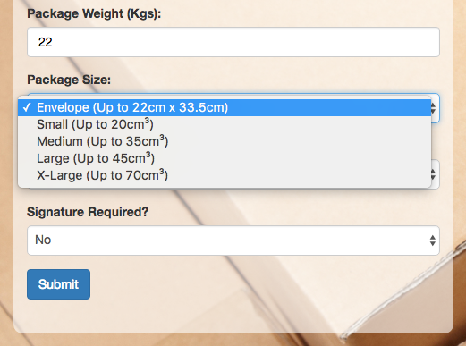

* This is the screenshot of the order form that contains the package details
* Here the maximum weight could be 22 kg (not more than that)
* Shows the drop down box regarding the size of the package **(values are taken from my research.)**

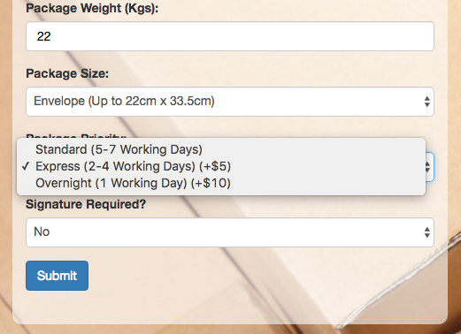

* Similarly, this is also the screenshot of the order form that contains the package details.
* Here it shows the drop down box regarding the package priority **(values are taken from my research.)**

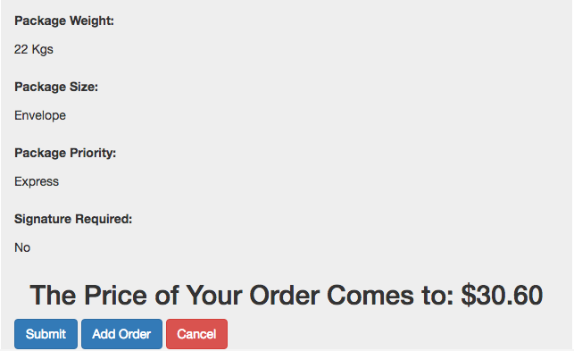

* This is the screenshot of the order confirmation page that has the price for the package in it
* The price is calculated on the basis of the weight and the priority. **(refer the evidence document).**

**Artefact 3**

Task: *Recorded the changes the client teams have made, their next sprint planning and the feedbacks given by our team to them in form of a word document*

Description:

In week eleven, during the presentation of the other team I recorder all changes that the development team has made since last sprint, the areas they will be focusing in the coming sprint and any the feedbacks given by the group.

The reason why this is considered to be an artifact is because the points recorded here can be used in the peer review assessment for completing the letter.

The document mainly focused on the expectations and the technical side of the presentation (Community organization).

Even though I am not the scrum master I recorded all the meeting minutes for my clarity

Evidence:



*Double Click here to information recorded.*

Benefits of recording the meetings in the website

Some of the points of the form the meeting is used while preparing the business letter.

Below is some screenshot that indicates that points from the meeting notes has been used as content in the peer review assessment (letter).

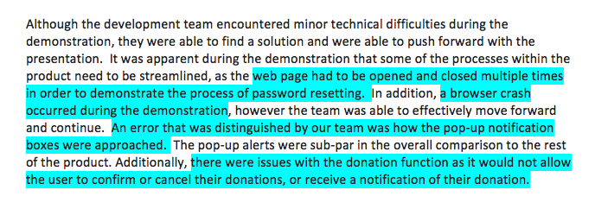

**Artefact 4**

Task: *Manual Testing the ‘Register account’ page*

Description:

The main purpose of this testing is to make sure that the user entering the valid details. It checks for the following things.

* Valid email address
* Valid contact number
* Checks for the geocode when entering the address details
* Checks for the Submit button.

Evidence:

*Double Click here to see the test case for the Register account page.*



Benefits to our website

Below is the screenshot of the testing done in the register account.

* The testing helps the user to re-enter the valid correct details. For instance, he/she forgot to enter “@” in the email address.
* This helps the user to verify that the number entered contain 10 digits in it.
* Implementation of the geocode, reduce the efforts of the user to type the whole address.

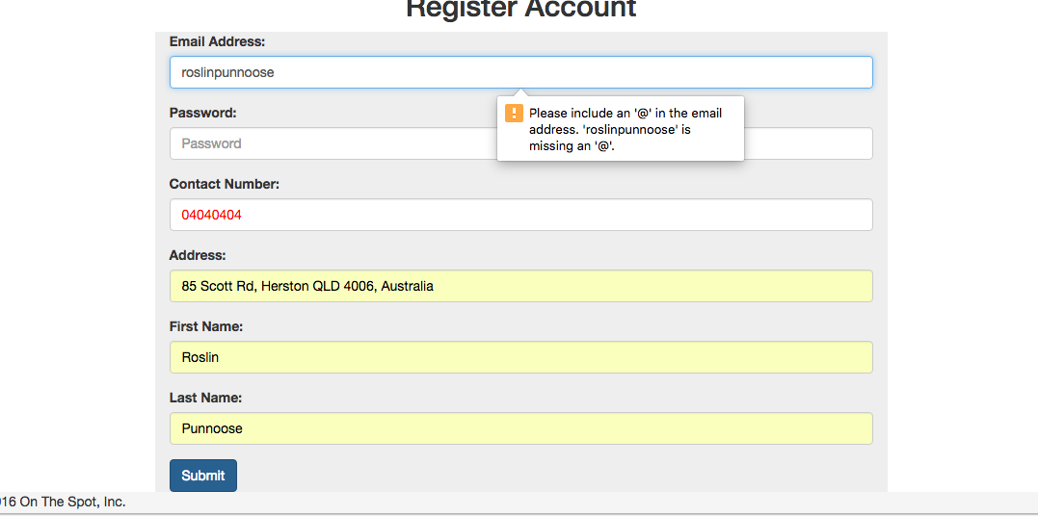

This makes the system more user friendly and accurate (in details)

**Artefact 5**

Task: *Manual Testing the ‘order details’ page (Focusing on validation).*

Description:

Similar to the above testing, the main purpose of this testing is to make sure that the user entering the valid details.

* It checks for the API geocode (when suburb name is entered.)
* Checks for valid contact number (reject if- letters, less or more than 10 digits is entered)
* Verifies the value entered in the package weight bar.
* Verifies that if the button is clicked, it navigates to the next page of the website.

Evidence:



*Double Click here to see the test case for the Order details page.*

Benefits to our website

Below is the screenshot of the testing done in the register account.

* The testing reduces the efforts of the user to type the whole address for instance, if the user type Herston it comes up with the API geocode which is Herston QLD 4006, Australia.
* It helps the user to re-enter the digits instead of letters as shown in the screenshot, when the user types the “ssssssss” instead by entering number, it comes up in red colour.
* As per the screenshot shown below this testing also checks if the user entered the weight more than 22kg. If the weight exceeds the it comes up in red colour.
* This is how the testing help us to make sure regarding all the information entered is validate or not.
* This eventually makes the website more professional in usage.

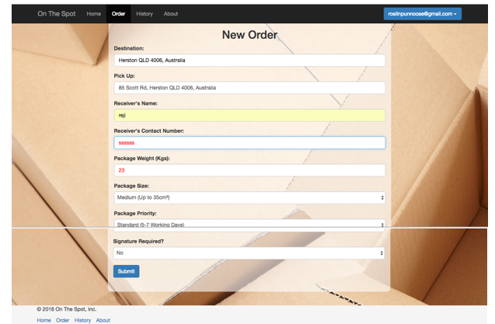

----------------------------------END OF THE REPORT----------------------------------------